Towards an effective poroelastic model for fractured porous media

Renato Poli1, Nicolas Espinoza1­, Kamy Sepehrnoori1

1The University of Texas at Austin, 200 E. Dean Keeton St., Austin, TX 78712, United States

# Abstract

* The concept of effective media as the homogeneous equivalent, keeping the 4 independent parameters.

* Effective stress based on Biot coefficient is valid for porous media, but not for plasticity, fractures etc.

* Fractured media micromechanics strongly differ from homogeneous porous media.

* Fracture behavior strongly influences the equivalent macroscopic mechanical behavior

* Fractures are difficult to characterize in lab, numeric effective models look more interesting

* We use inhouse simulator, 3D, discrete fractures to assess macroscopic mechanical impact of fractures

* We first present a thorough validation of the simulator and then use the simulator in automated batch runs for calculating the effective parameters

* We can see increase of the biot coefficient, decrease in drained bulk modulus and increase in biot modulus etc

* The validity is bound by small strains and linear elastic behavior of the whole system.

*Keywords: Naturally Fractured Reservoirs; Numerical methods; Linear poroelasticity; Biot consolidation; Skempton coefficient.*

TARGET JOURNAL: JMPS - Journal of the Mechanics and Physics of Solids

A few rules for the pictures:

1. Use inkscape and pyplot
2. The drawing area must be 130x75mm (short-horizontal), 190x75 (large-horizontal) or 80x75mm (singlecol)
3. The hight may be larger if needed
4. Text must be Cambria Math 10pt
5. Export in 1000 dpi, png format, white background
6. Do not resize the pictures

# INTRODUCTION

Overview of fractured reservoirs

Significant oil reserves reside in naturally fractured reservoirs. In fact, the existence of joints is practically certain in every oil and gas accumulation. Their impact in fluid flow as preferential paths and in the stress-strain mechanical relationship as planes of high deformability is a necessary definition in early stages of the reservoir characterization. As a matter of fact experimental and field data, and thorough investigation show undeniably that, in many cases, the performance of such systems rely on the existence of such joints and not recognizing their existence may lead to abandonment of economic fields (Aguilera, 1998; Narr et al., 2006; Nelson, 2001; Zareidarmiyan et al., 2021).

If reservoir and geotechnical modelers do not embed the fractures into their models and instead use laboratory results for flow and mechanics as representative samples, the assessment may carry large error. For that, significant work has been done in the development of effective (or equivalent) models for fractured media to enable consisten numerical characterization of those within reasonable computational effort (Bandis et al., 1983; Barton and Bandis, 1982; Guéguen and Kachanov, 2011; Long et al., 1982; Oda, 1986).

Motivation, objectives

The mechanical behavior in the fracture domain and the fluid interaction with the fracture walls links to the understanding of the effective stress principles. The concept of effective stress itself is non-unique as it depends on the context of the analysis (Boutéca and Guéguen, 1999). A number of classic experimental and theoretical work has shown that volumetric strain of elastic continuum, for example, follows Biot’s effective stress while failure criterion respond better to Terzaghi’s effective stress (Brace and Martin, 1968; Cornet and Fairhurst, 1974; Rice, 1977). That means that (i) fracture strength criteria is a function of the difference between the stress field and that (ii) the fracture pressure and the total stress on the fracture surface must in equilibrium in an open fracture.

While extensive experimental work has been done in small samples for fractured media, mechanical testing of fractured rock in a larger scale is still limited. For that, numerical simulations and analytical approaches are useful to upscale the laboratory outcomes into the expected behavior of large-sized fractured volumes. In full-scale reservoir geomechanics models, for example, side can length over , which is unachievable for direct experimental investigation. Finally, the fracture parameters are always going to be uncertrain. The goal of any numerical upscaling workflow is not to deny this fact, but to provide plausible ranges for the analysis.

The specific stiffness of a fracture measures the traction (or cohesion) between the two sides of a fracture as a function of their aperture. The specific stiffness is strongly correlated to its contact area and roughness, which is inversely proportional to the fracture aperture. In summary, the more tensile is the stress at the fracture surfaces, the larger is the fracture aperture, the smaller is contact area and the smaller is its specific stiffness. (Bandis et al., 1983; Pyrak-Nolte and Morris, 2000)

Therefore, the effective stress-strain relation of a NFR is non-linear in nature and the elastic formulation here discussed relies on linear local approximation. Particularly, when near tensile situations, the effective stiffness of the reduces rapidly, and one may assume that beyond a tensile threshold fracture specific stiffness is negligible. Such awareness suggest that the effective stiffness must not be static throughout field scale numerical models, but should rather be reduced in areas of effective tension.

This observation is particularly relevant during cold fluid injection. Assuming a constant pressure, the lower temperature reduces the total stress of the area, and the effective stress tends to tension and to initiate fractures. However, as the lower fracture specific stiffness translates into the effective parameters, the temperature impact on stress is reduced accordingly, and the system reaches and equilibrium.

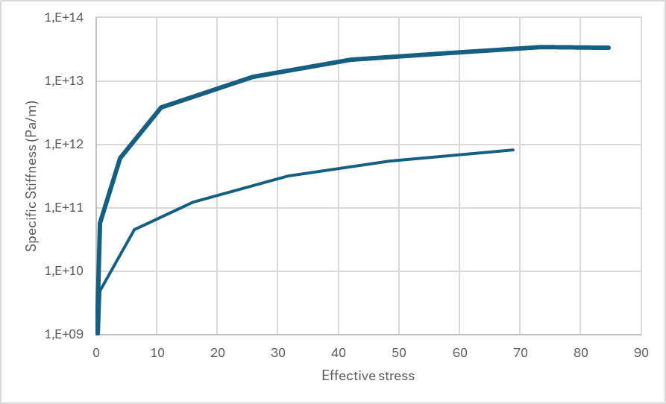

Figure 1 – expected specific stiffness for fractures as a function of the Terzaghi’s effective stress. Note that the specific stiffness decreases abruptly when the systems approximate tensile stresses

The objective of this paper is to provide a comprehensive sensitivity analysis of what is to be expected of the parameters of an effective linear poroelastic model representing naturally fractured porous media. Based on high fidelity numerical framework, we provide robust recommendations and rules-of-thumb for field-scale geotechnical modeling frameworks which, to our understanding, is missing in the literature.

Recent numerical models for fractured rocks, homogenization

In the linear mechanics literature, a number of analytical models were proposed to derive effective parameters mostly focused on geophysical application – e.g. (Grechka and Kachanov, 2006). The realization that the macroscopic impact of the fractures is proportial to the cubic of the radius of circular fractures incur that larger fractures dominate the mechanical behavior, while small fractures can be neglected in the analysis.

The use of numerical approach to determine the equivalent elastic compliance tensor for fractured rock masses using numerical approaches with a commercial simulators has also been reported with success. We remark, however, the less flexibility provided by such tools, which limit the investigation to a few runs (Min and Jing, 2003). (Marinelli et al., 2016) explores a multiscale finite element strategy with cohesive elements to understand the REV as an effective media. (Chen et al., 2020; De Simone et al., 2023) also discuss the effective stress coefficient derivation in saturated fractured using numerical models.

Although very insightful, the reviewed work lack a sense of generality and focus either on very specific distribution of fractures or on a single parameter. As the fracture network impacts the poroelastic behavior as a whole, it looks more interesting to assess the parameters altogether, in a probabilistic sense.

Development of PMF!3D

We introduce the inhouse numerical simulator PMF!3D as the main investigation tool. PMF!3D uses an automated reproducible framework and is integrated with a high performance computing infrastructure for extensive testing. To our knowledge, the proposed workflow uses the most efficient open-source technologies currently available, extensively exploring parallelism and scripted pre and post processing of the results.

Prior to the implementation of PMF!3D, Poli et al. (2021) showed a FEM 3D simulator with fracture propagation and adaptive mesh refinement, which is now expanded to 3D. The complexity increase in meshing and computational cost is remarkably higher, challenging the design towards a high performance implementation and the use of the best libraries currently available.

PMF!3D uses the idea of zero-width cohesive elements to model accurately conforming fractures in a 3D environment, in which, the shear and normal cohesive are controlled independently. To the authors knowledge, the first authors to propose this approach were (Cundall, 1971; Ghaboussi et al., 1973; Goodman et al., 1968).

The analysis is currently limited to isotropic parameters. Although the presence of fractures generate anisotropic behavior, isotropic homogenization is a common practice in most of the modeling workflows. That means that, small scale anisotropy is approximated isotropically to the model element level, whereas macro-scale anisotropy is explicitly incorporated in property distribution among the cells.

Paper flow

This paper is organized as follows. Next section presents the formulation and development aspects the simulator PMF!3D up to the computational processing framework, followed by validation runs. In results conceptual runs with a fixed and symmetric set of fractures provides sensitivity analyses of what is expected in the effective poroelastic media. A set of anisotropic testcases then shows the errors expected when a fractured medium is approximated by an isotropic effective REV. Finally, the results of a comprehensive Monte-Carlo analysis propose rules-of-thumb for designers indending to tweak laboratory parameters into effective ones on field-scale reservoir models.

Table 1 – Symbols and relevant definitions for linear poroelasticity

|  |  |  |
| --- | --- | --- |
| Symbol | Description | Unit |
|  | Cauchy (total) stress tensor (positive for tension, negative for compression) |  |
|  | Biot effective stress (positive for tension, negative for compression) |  |
|  | Terzaghi effective stress (positive for tension, negative for compression) |  |
|  | Isotropic applied stress field (positive for tension, negative for compression) |  |
|  | Biot coefficient |  |
|  | Displacement tensor |  |
|  | Isotropic shear modulus |  |
|  | Drained Young modulus |  |
|  | Isotropic Poisson ratio |  |
|  | Fluid content of the (positive for fluid added) |  |
|  | Hidraulic conductivity |  |
|  | Gravity force |  |
|  | Fluid viscosity |  |
|  | Rock intrinsic permeability |  |
|  | Mobility coefficient. |  |
|  | The permeability and the ration between permeability and viscosity in the fracture domain |  |
|  | Fluid density |  |
|  | Biot modulus |  |
|  | Fluid storage coefficient in constant strain |  |
|  | Pore pressure, positive for compression. |  |
|  | Drained bulk modulus. |  |
|  | Undrained bulk modulus () |  |
|  | Skempton coefficient |  |
|  | Variation of volume of voids from configuration to configuration |  |
|  | Variation of volume of solids from configuration to configuration |  |
|  | Bulk volume of the |  |
|  | Representative elementary volume |  |
|  | Poroelastic stiffness fourth-order tensor |  |
|  | Terzaghi effective specific stiffness normal to the fracture surface |  |
|  | Total specific stiffness tangential to the fracture surface, expressed in the fracture local coordinate system |  |
|  | Total cohesive traction in the fracture surface expressed in the fracture local coordinate system |  |
|  | Terzaghi effective cohesive traction normal to the fracture surface. |  |
|  | Total cohesive traction in the fracture surface expressed in the global coordinate system |  |
|  | Biot effective cohesive traction in the fracture surface expressed in the global coordinate system |  |
|  | Terzaghi effective cohesive traction in the fracture surface expressed in the global coordinate system |  |
|  | Elevation |  |
|  | Time derivative |  |
|  | Strain tensor. |  |
|  | Volumetric strain |  |
|  | Dirak delta |  |
|  | Elevation head |  |
|  | Unitary normal and tangential vectors to the matrix faces, expressed in the global coordinate system |  |
|  | Rotation matrix from local () to global () coordinate system. |  |
|  | Jump operator applied to the displacement vector |  |
|  | Displacement vector across a discontinuity. The superscript and identify the opposing sides of the discontionuity. |  |
|  | The aperture normal to the fracture surface. |  |
|  | Consolidation coefficient. |  |
|  | Storage coefficient. |  |
|  | Pressure of the system under undrained conditions. |  |
|  | Poroelastic stress coefficient. |  |

# FORMULATION

This section presents the mathematical formulation for the in-house simulator PMF!3D in the strong form. The numerical domain is split in a *continua domain* to represent the fluid flow and mechanical deformation of the intact rock, and a *fracture domain* to represent fluid flow and mechanical equilibrium along rock joints.

The continua constitutive law follows entirely the linear poroelasticity as originally proposed by (Biot, 1941) and more recently comprehensively described in text books (Cheng, 2016; Wang, 2000). In the fracture domain, the models for mechanical equilibrium and flow continuity in the fracture domain follow principles of local linearity, as originally proposed by (Cundall, 1971; Goodman et al., 1968).

Symbols and fundamental formulations of poroelasticity used in this work are presented in Table 1 for clarity. This work uses indicial notation for vectors and tensors to favor implementation of low level computer routines. Repeated indices in a product represent the Eistein summation throughout the dimensions in use and can be promptly translated into looped iterations. When omitted, are independent iterators for the global coordinate system .

## Continua domain: linear poroelasticity and flow continuity

In linear poroelasticity, the effective stress tensor is linearly related to the strain tensor by

, (1)

where is the stiffness tensor which, for linear elastic media is

. (2)

The mechanical equilibrium condition for a is given by the divergence-free condition of the Cauchy total stress tensor, that is

. (3)

Using relations in Table 1 and observing the symmetric properties of it is clear that

, (4)

which are said to be the constitutive partial differential equations for the mechanical equilibrium of the continua.

To achieve flow continuity, the rate of increment of fluid content must balance the fluid entering minus leaving the continua , that is

. (5)

Darcy’s law states that the fluid flow through the is given by the inner product of the hydraulic conductivity tensor and the gradient of the hydraulic head:

. (6)

Considering horizontal single-phase isotropic flow, gravity is neglected, and the flow equilibrium constitutive partial differential equation becomes

(7)

## Fracture domain: flow continuity and mechanical equilibrium

To achieve flow continuity in the fracture domain, the rate of increment of the normal aperture must balance the fluid entering minus the leaving the fracture , that is

on . (8)

This work considers the system is on steady state, so that, in the fracture domain, the fluid flow is in equilibrium with the surrounding continua and the flow across the fracture surface is negligible.

Inside the fracture domain, in the direction normal to the fracture surface, the fluid is free to flow, and no pressure gradient is expected. Along the fracture, on the other hand, the fluid flow equations can be reduced in dimension and characterized by a tangential transmissibility relating fluid flow to the pressure gradient. This formulation is normally referred to as the *cubic law* (Lomize, 1951; Witherspoon et al., 1980). Hence, the fluid flow along the fracture becomes

on . (9)

Note that, for the present study, is assumed constant and high enough for steady-state observations.

The fluid content inside the fracture can be approximated by the normal aperture , also reducing the dimensionality of the domain, and the flow inside the fracture is fully described by

(10)

The mechanical equilibrium in the fracture domain is controlled by cohesive forces described in the local coordinate system . The parameters are the specific stiffness in the normal and tangential directions to control the fracture mechanics. For the present work, in all cases. Hence, the fracture Terzaghi effective cohesive traction in the local coordinate system is

(11)

where

  . (12)

Note that a zero stiffness represent a cohesion free fracture, meaning that the fracture surfaces do not interact. However, the fluid pressure in side the fracture still acts as a total normal stress with or, equivalently, .

The rotation tensor must be applied to rotate (11) into the global coordinate system. As the aperture in the local coordinate system is

, (13)

the Terzaghi effective cohesive traction in the global coordinate system is

, (14)

and observing of the orthogonal nature of the rotation matrix,

, (15)

the traction acting on the fracture surface in global coordinates is

. (16)

Lastly, the Biot effective cohesive traction on the face of the fracture as

. (17)

The final expression for the is

on (18)

# NUMERICAL SOLUTION

This section describes the numerical strategy to approximate the partial differential equations described above.

The space discretization follows the Finite Element Method as in (Hughes, 2000). Numerical stability is ensured by LBB stability condition using second order basis functions for displacement variables and first order shape functions for pressure (Murad and Loula, 1994). The fracture model use elements of reduced dimension, that is, the dimension normal to the fracture surface is analytically reduced as flow and traction boundary conditions for the continua and only the tangential flow is solved numerically as 2D surface elements.

Time marching follows second-order implicit Crank-Nicholson timestepping, with proven gain in performance and accuracy compared to first-order implicit schemes during validation tests.

## Space discretization using the Finite Element Method

This section presents the formal statement of the problem in a Finite Element environment. Table 2 summarizes definitions for the development that follows. Further strict mathematical background are found in (Hughes, 2000).

Equations (4, 7,10,18) comprise the strong form of the problem, rewritten below for clarity:

on

on

on

on

and on (19)

For the coupling between the fracture and continua domains, it is convenient to first the weak form of equation (10) and perform the integral by parts:

Ignoring the fluid flow normal to the fracture surface (second term), the fluid exchange with the continua becomes

that is the coupling term.

Splitting the continua boundary into fracture boundary and non-fracture , the weak form that derives from the continua domain equations (4, 7) is

Find and , such that and

Continua mechanics:

Continua flow and mass balance:

where

. (20)

Replacing and at the fracture boundary , we couple the continua and fracture domain in a single weak form:

Find and , such that and

Continua mechanics:

Continua flow and mass balance:

Fracture mechanics:

Fracture flow and mass balance:

(21)

and the Galerkin formulation is

Find and , such that   
 and

Continua mechanics:

Continua flow and mass balance:

Fracture mechanics:

Fracture flow and mass balance:

. (22)

The system is now split in elements and nodes to be evaluated in a linear system of equations. The iterators are introduced to represent the mesh nodes. The nodal values are the unknowns of the linear equation system

, (23)

which is obtained by approximating by use of the linear combinations of the shape functions and :

and . (24)

Finally, the following expression describes the linear equation system , in which the system parameters are assumed locally constant and leave the integrals:

Continua mechanics:

Continua flow and mass balance:

Fracture mechanics:

Fracture flow and mass balance:

(25)

## Time discretization using Crank-Nicholson

The time derivatives in equation (25) are linearly expanded as

where the term is known from the previous iteration or from initial conditions, and the term is the unknown.

The second-oder implicit Crank-Nicholson scheme approximates the terms , such that

Where the coefficient of the unknowns comprise the tangent matrix, while the coefficients of the can be fully evaluated and sums into the right hand side vector . To our experience, the second-order time approximation has show itself accurate and efficient, requiring less timesteps when compared to first-order implicit or explicit system.

Table 2 – Symbols and relevant definitions for the Finite Element Method framework

|  |  |
| --- | --- |
| Symbol | Description |
|  | Collection of the trial solutions for displacement. |
|  | Collection of the trial solutions for pressure. |
|  | Collection of the test solutions for displacement. |
|  | Collection of the test solutions for pressure. |
|  | The discrete counterparts of the function spaces |
|  | Linear combination of shape functions to approximate . |
|  | Linear combination of shape functions to approximate . |
| , | Heterogeneous (non-zero) Dirichlet (natural) constraints for and . |
|  | Approximation of the jump operator across a discontinuity. The positive () superscript represents the displacement on the positive face of the fracture and the negative () represent the displacement in the negative face of the fracture. |
|  | Number of nodes in the mesh. |
|  | inner product of functions and over the continua domain |
|  | inner product of functions and over the fracture domain |
|  | norm of over the domain . |
|  | The Hilbert space is defined as the collection of square integrable functions (finite norm). |
|  | inner product of functions and over the domain . |
|  | norm of over domain . |
|  | The Sobolev space is defined as the collection of functions with finite norm. |
| , | Continua and fracture domains |
|  | Boundary domain of the continua, excluding the fracture domain |
|  | Volume of fluid flowing normal to a surface |
|  | Volume of fluid flowing inwards from the continua to the fracture domain. |

## Computational framework

The use of a high performance computational framework is directly related to the quality of the simulator, as it enables recurrent testing. This section describes and credits the libraries and tools used to build a automated reproducible design and test environment.

The mesh generation ensgine uses *gmsh* python API (Geuzaine and Remacle, 2009). For this work, the fracture distribution in space is an important control variable, since the objective is not only for a specific set of fractures, but the fracture impacts on the effective poroelastic model in a general sense. That means the mesh generation is done using mesh recipes on a per-testcase base, without user interaction.

Conforming fractures are embedded in the domain by *gmsh*. The simulation framework splits the nodes on both sides of each fracture so that the displacement in each side is independent and the fracture mechanics constitutive behavior is assigned between them.

The numerical framework is designed in C++ using open-source libraries *libmesh* (Kirk et al., 2006), PETSc (Balay et al., 2024) and their dependencies as lower level mathematical implementations. The linear solver solution that has shown the most promising results was the Algebraic Multigrid Implementation *BoomerAMG,* available in Hypre library (Henson and Yang, 2002; hypre, n.d.), along with the standard Conjugate Gradients linear solver.

Test, pre- and post- processing are implemented in *Python* and *GNU make* in an automated and reproducible framework. This framework runs in a light terminal which spawns and control the input, output into an high performance computing infrastructure (LNCC, n.d.)

# ESTIMATION OF EFFECTIVE PARAMETERS

This section describes the methodology to derive effective isotropic poroelastic parameters that best describe a fractured media. While it is well known that fractures add mechanical and hydraulic anisotropy to the media, most modelers and simulators restrict parameters to the effective parameters of an isotropic linear homogeneous material. This means that small scale anisotropy is upscaled into an effective isotropic medium, whereas macroscale anisotropy is distributed in an element-by-element basis.

As previously discussed, the linear poroelastic effective in consideration model comprises 4 independent parameters, namely , , , . The three first parameters are *drained* in nature, that is, they are analogous to their linear mechanics counterparts if and only if no pore pressure variation is observed (). The Biot modulus is related to the fluid compressibility and storage capacity, so it requires a *undrained* investigation, controlling the mechanical response of the sample to the pore pressure variation. The permeability of the media is assumed to be high enough so that the sample is under a negligible pressure gradient at all times, and the fluid viscosity is assumed to be constant.

Fig. 1 shows the numerical experiments that provide enough measurements to derive the effective media parameters of the sample. The testcase flow is set in 5 steps: (a) model initialization with zero displacement and pressure; (b) drained isotropic load to determine effective and ; (c) drained single-side load to determine ; (d) model reinitialization with zero displacement and pressure; (e) undrained isotropic load to determine .

In all cases, the boundary axias displacement is forced to be uniform by tying every degree of freedom together in a rigid boundary constraints. The overall average pore pressure and the total variation of fluid content are derived an element-by-element basis, considering both the continua and the fracture domains. The poroelastic parameters are then determined according to the formulae in Tab. 3 during post-processing of the models.

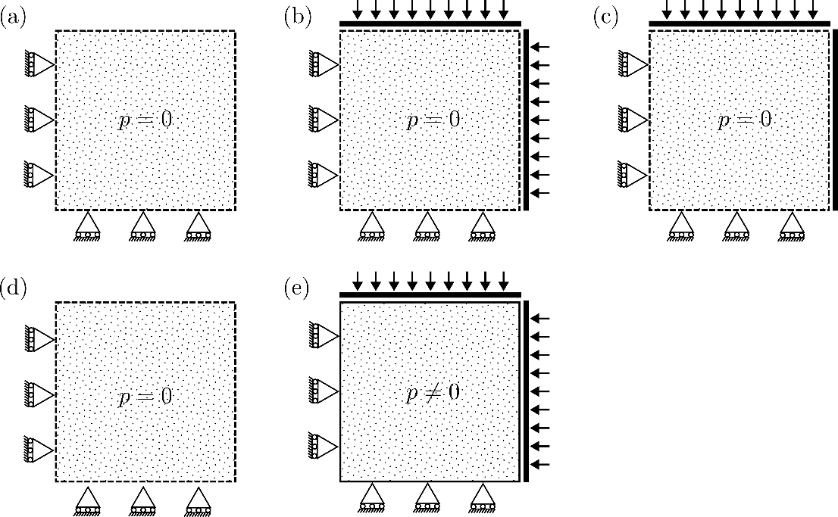

Figure 2 – Step-by-step diagram of the numerical experiment for the estimation of the effective poroelastic parameters. First, drained tests () estimate , and (Fig. a-c). Then one undrained test () estimates the Biot Modulus (Fig. d,e). The diagram is in 2D for clarity, experiment is 3D.

Table 3 – Step-by-step computation of the effective poroelastic media parameters after numerical experiment (Fig 2).

|  |  |
| --- | --- |
| 1. Compute volumetric strain |  |
| 2. Compute effective bulk modulus |  |
| 3. Compute fluid content |  |
| 4. Compute effective Biot coefficient |  |
| 5. Compute effective Poisson ratio |  |
| 6. Compute effective Skempton coefficient |  |
| 7. Compute effective Biot modulus |  |

# RESULTS

## MODEL VALIDATION

### Linear poroelasticity

Terzaghi consolidation

(Von Terzaghi, 1923)

|  |  |
| --- | --- |
|  |  |
|  |  |
|  |  |
|  |  |
|  |  |

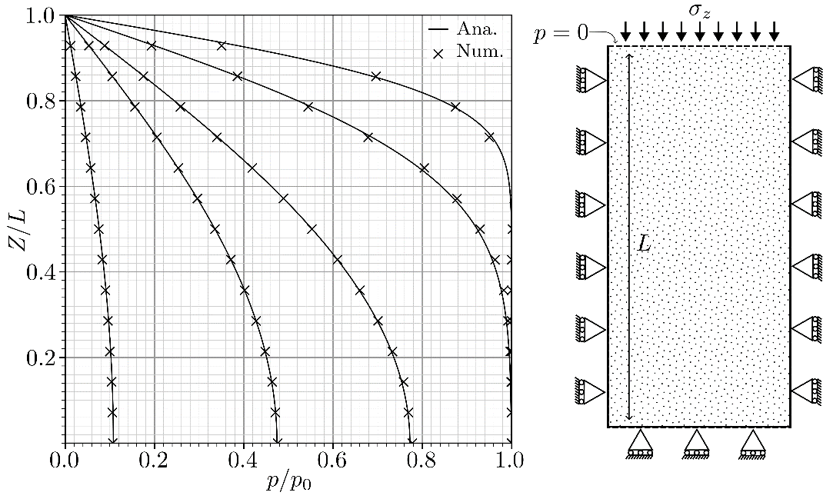

Figure 3 – Terzaghi consolidation problem for selected timesteps (), in good agreement with the analytical solution.

Table 2 – Symbols for Terzaghi’s consolidation test.

|  |  |  |
| --- | --- | --- |
| Symbol | Description | Unit |
|  | Adimentional time. |  |
|  | Total stress acting normal to the top face of the domain. |  |
|  | Position. |  |
|  | Length of the domain. |  |

### Mandel’s problem

(Mandel, 1953)

|  |  |
| --- | --- |
|  |  |
|  |  |
|  |  |
|  |  |
|  |  |

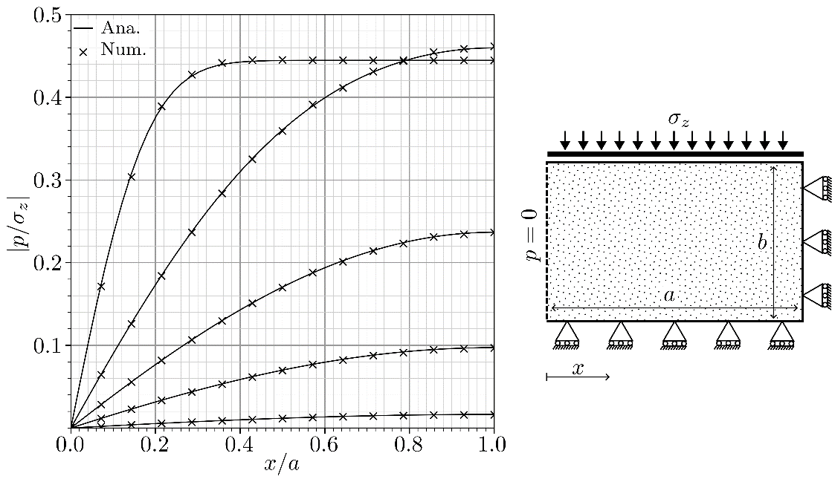

Figure 3 – Mandel’s problem for selected timesteps (), in good agreement with the analytical solution.

Table 2 – Symbols for Mandel’s problem

|  |  |  |
| --- | --- | --- |
| Symbol | Description | Unit |
|  | Adimentional time. |  |
|  | Total stress acting normal to the top face of the domain. |  |
|  | Position. |  |
|  | Domain’s half length. |  |
|  | Domain’s half height. |  |

### Fracture specific cohesion

Shear and normal behavior of a set of fractures.

|  |  |
| --- | --- |
|  |  |
|  |  |
|  |  |

|  |  |
| --- | --- |
|  |  |
|  |  |
|  |  |

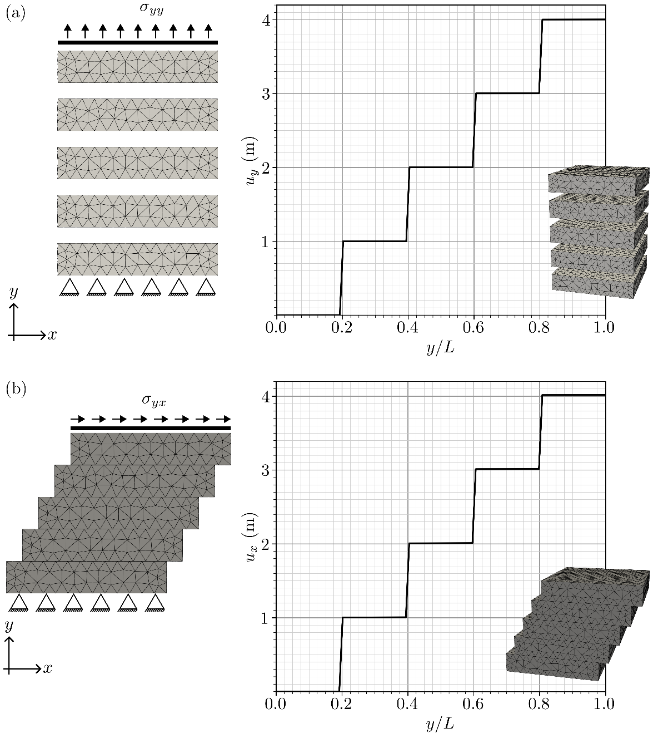

Figure 5 – Validation of the fractures specific stiffness in the (a) normal and (b) shear directions. The mesh contains 4 fracture planes with linear non-zero stiffness assigned. As numerically , a jump of is expected across each fracture plane in the direction of the external stress.

### Sneddon solution

(Sneddon, 1946)

|  |  |
| --- | --- |
|  |  |
|  |  |
|  |  |
|  |  |

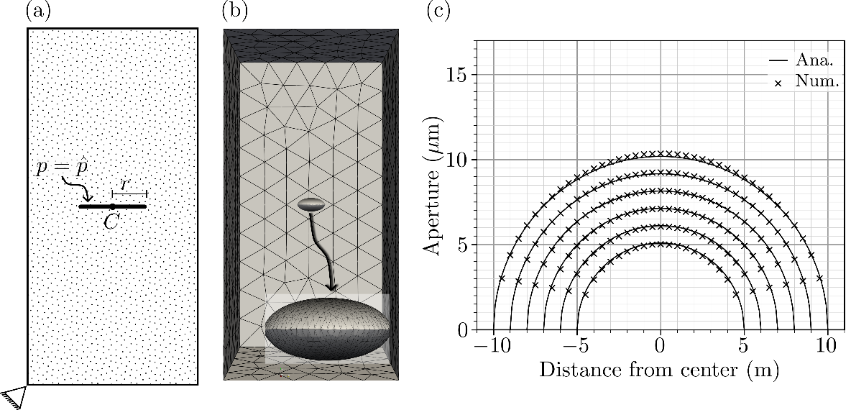

Figure 5 – Validation using Sneddon’s solution for a circular fracture located in the center of a large domain, using a constant pressure at the fracture surfaces as stimulus. (a) Diagram of the boundary conditions for the test. (b) 3D diagram of the test, with the displacement magnified and applied to the mesh. (c) Comparison of the analytical and numerical solution for different fracture radius . The maximum observed relative error was .

### Mass balance of an open fracture

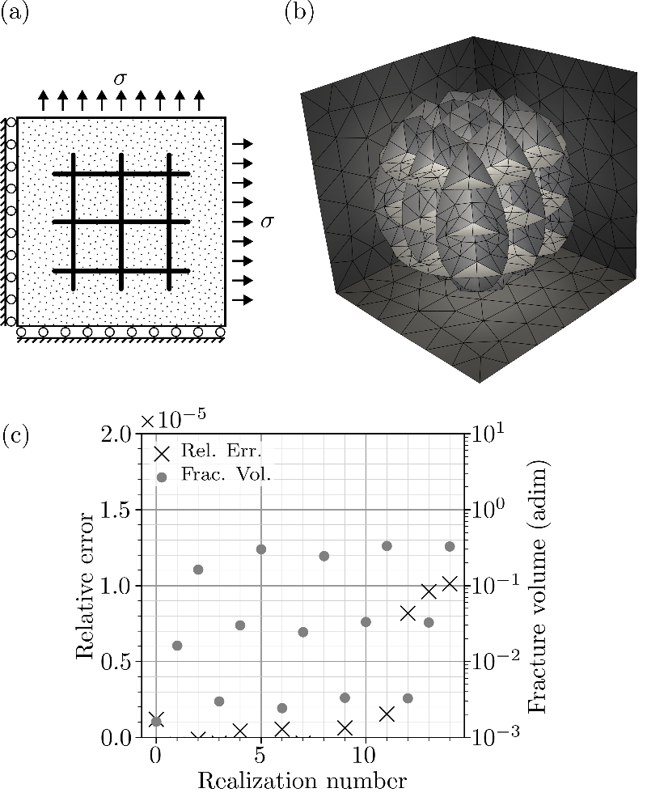

Figure 7 – Validation of the volume balance of different sets of fractures. A relative error below is expected. (a) Diagram of the experiment. (b) 3D illustration of the domain. (c) Results for 15 tests with different stress and fracture density. Fracture volume was normalized as it carries no meaning in this context.

## SYMMETRIC ORTHOTROPIC FRACTURE

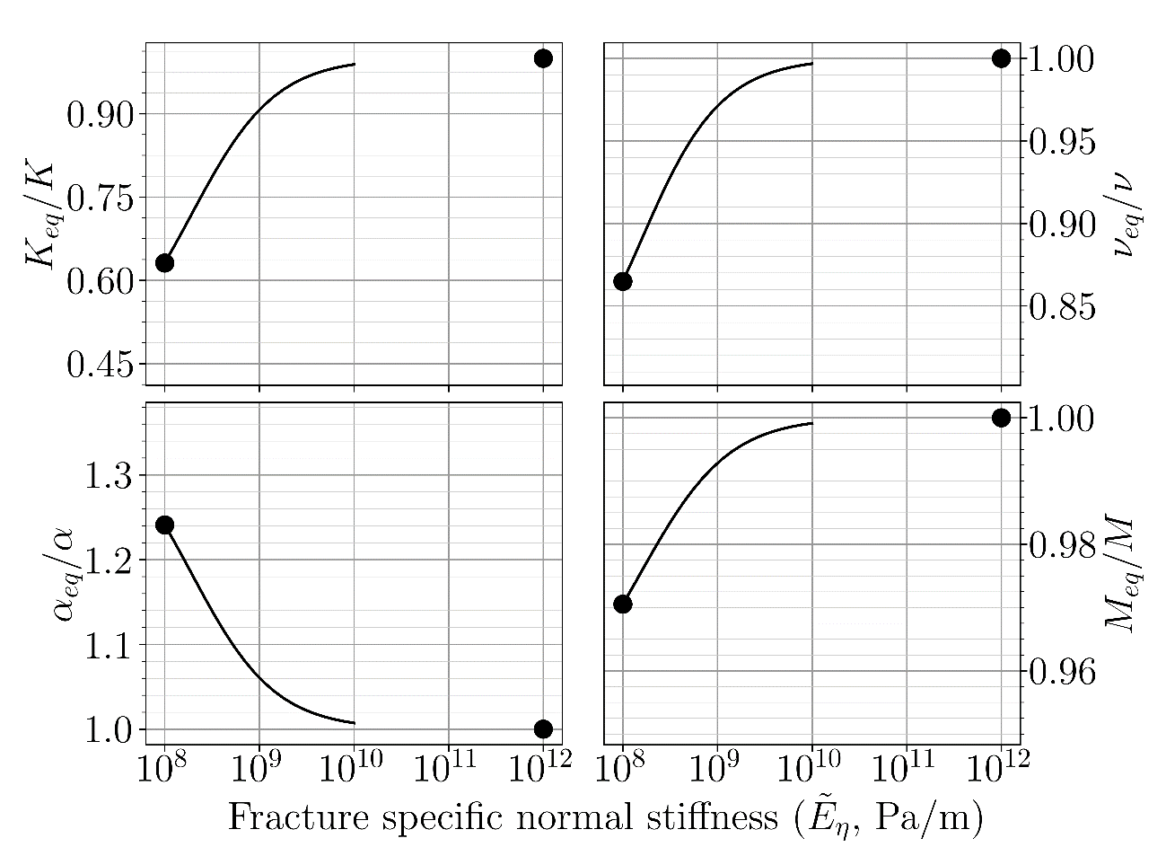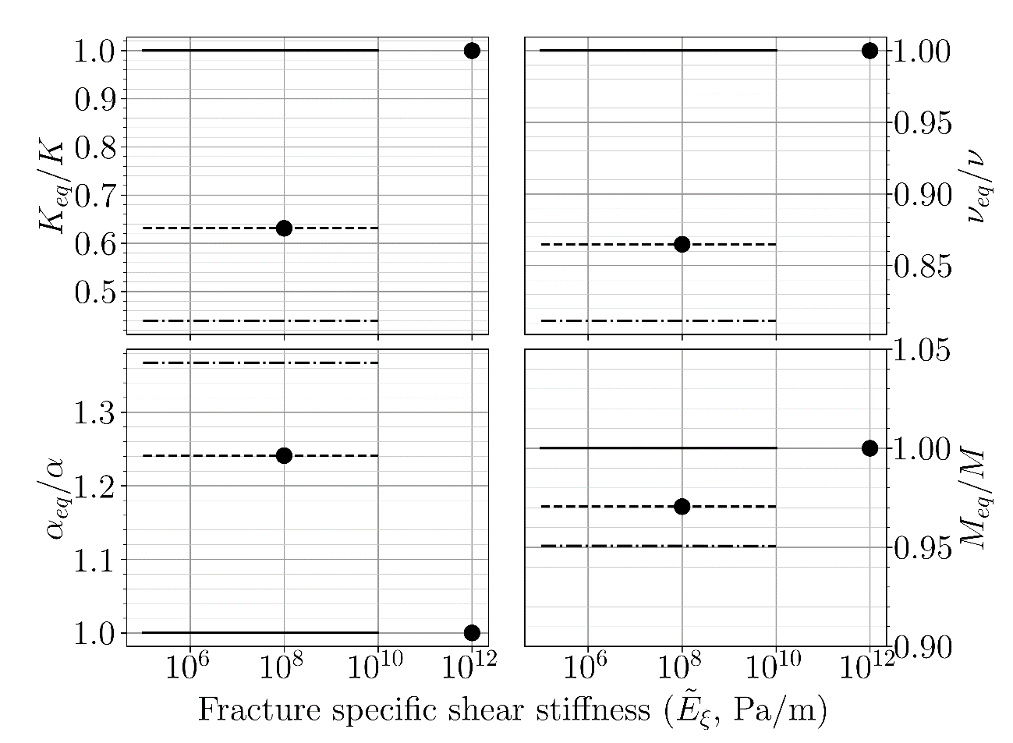

## VTI FRACTURE (horizontal frac)

*(Not yet run)*

## VERTICAL FRACTURES

*2 SETS OF VERTICAL FRACTURES AND NO HORIZONTAL FRACTURES*

*(Not yet run)*

## MONTE CARLO

# DISCUSSION AND FINAL REMARKS

## Recommendations to modelers, takeaways

## Laboratory results must be upscaled in a NFR into an effective poroelastic model

## There are clear trends for each parameter of the effective model

## Fracture orientation does not matter for Biot and Skempton, intensity does

## Propose ranges for parameters within the studied models

## Fracture parameters must be addressed as uncertainties of the system

## The lower bound of the ranges should be higher than the laboratory results

## Next steps: consider temperature, plasticity

# REFERENCES

Aguilera, R., 1998. Geologic aspects of naturally fractured reservoirs. The Leading Edge 17, 1667–1670.

Balay, S., Abhyankar, S., Adams, Mark.F., Benson, S., Brown, J., Brune, P., Buschelman, K., Constantinescu, Emil, M., Dalcin, L., Dener, A., Eijkhout, V., Faibussowitsch, J., Gropp, W.D., Hapla, V., Isaac, T., Jolivet, P., Karpeev, D., Kaushik, D., Knepley, M.G., Kong, F., Kruger, S., May, D.A., McInnes, L.C., Mills, R.T., Mitchell, L., Munson, T., Roman, J.E., Rupp, K., Sanan, P., Sarich, J., Smith, B.F., Zampini, S., Zhang, H., Zhang, J., 2024. PETSc Web page.

Bandis, S.C., Lumsden, A.C., Barton, N., 1983. Fundamentals of rock joint deformation. International Journal of Rock Mechanics and Mining Sciences & Geomechanics Abstracts 20, 249–268.

Barton, N., Bandis, S., 1982. Effects of block size on the shear behavior of jointed rock, in: ARMA US Rock Mechanics/Geomechanics Symposium. Berkeley, CA, pp. 739–760. https://doi.org/10.2307/jj.9669308.78

Biot, M.A., 1941. General theory of three‐dimensional consolidation. J Appl Phys 12, 155–164.

Boutéca, M., Guéguen, Y., 1999. Mechanical Properties of Rocks: Pore Pressure and Scale Effects, Oil & Gas Science and Technology-Rev. IFP.

Brace, W.F., Martin, R.J., 1968. A test of the law of effective stress for crystalline rocks of low porosity. International Journal of Rock Mechanics and Mining Sciences 5, 415–426. https://doi.org/10.1016/0148-9062(68)90045-4

Chen, S., Zhao, Z., Chen, Y., Yang, Q., 2020. On the effective stress coefficient of saturated fractured rocks. Comput Geotech 123. https://doi.org/10.1016/j.compgeo.2020.103564

Cheng, A.H.-D., 2016. Poroelasticity. Springer International Publishing, Switzerland. https://doi.org/10.1007/978-3-319-25202-5

Cornet, F.H., Fairhurst, C., 1974. Influence of Pore Pressure on the Deformation Behavior of Saturated Rocks, in: Proc. 3rd Congress ISRM. National Academy of Sciences, Denver, pp. 638–644.

Cundall, P.A., 1971. A computer model for simulating progressive large-scale movements in blocky rock systems. Rock fracture: proceedings of the International Symposium on Rock Mechanics. 1, 129–136.

De Simone, S., Darcel, C., Kasani, H.A., Mas Ivars, D., Davy, P., 2023. Equivalent Biot and Skempton Poroelastic Coefficients for a Fractured Rock Mass from a DFN Approach. Rock Mech Rock Eng 56, 8907–8925. https://doi.org/10.1007/s00603-023-03515-9

Geuzaine, C., Remacle, J., 2009. Gmsh: A 3‐D finite element mesh generator with built‐in pre‐and post‐processing facilities. Int J Numer Methods Eng 79, 1309–1331.

Ghaboussi, J., Wilson, E.L., Isenberg, J., 1973. Finite element for rock joints and interfaces. Journal of the soil mechanics and foundations division 99, 833–848.

Goodman, R.E., Taylor, R.L., Brekke, T.L., 1968. A model for the mechanics of jointed rock. Journal of the soil mechanics and foundations division 94, 637–659.

Grechka, V., Kachanov, M., 2006. Effective elasticity of fractured rocks: A snapshot of the work in progress. Geophysics 71. https://doi.org/10.1190/1.2360212

Guéguen, Y., Kachanov, M., 2011. Effective elastic properties of cracked rocks - An overview. Mechanics of crustal rocks 73–125.

Henson, V.E., Yang, U.M., 2002. BoomerAMG: A parallel algebraic multigrid solver and preconditioner. Applied Numerical Mathematics 41, 155–177. https://doi.org/10.1016/S0168-9274(01)00115-5

Hughes, T.J.R., 2000. The finite element method: linear static and dynamic finite element analysis, Reprint. ed. Dover Publications, Inc.

hypre: High Performance Preconditioners [WWW Document], n.d. URL https://llnl.gov/casc/hypre

Kirk, B.S., Peterson, J.W., Stogner, R.H., Carey, G.F., 2006. libMesh : a C++ library for parallel adaptive mesh refinement/coarsening simulations. Eng Comput 22, 237–254. https://doi.org/10.1007/s00366-006-0049-3

LNCC, n.d. Santos dumont supercomputer [WWW Document]. URL https://sdumont.lncc.br/

Lomize, G.M., 1951. Water flow through jointed rock (in Russian).

Long, J.C.S., Remer, J.S., Wilson, C.R., Witherspoon, P.A., 1982. Porous media equivalents for networks of discontinuous fractures. Water Resour Res 18, 645–658.

Mandel, J., 1953. Consolidation des sols (étude mathématique) (Consolidation of soils (mathematical study))). Geotechnique 3, 287–299.

Marinelli, F., Van Den Eijnden, A.P., Sieffert, Y., Chambon, R., Collin, F., 2016. Modeling of granular solids with computational homogenization: Comparison with Biot’s theory. Finite Elements in Analysis and Design 119, 45–62. https://doi.org/10.1016/j.finel.2016.05.003

Min, K.B., Jing, L., 2003. Numerical determination of the equivalent elastic compliance tensor for fractured rock masses using the distinct element method. International Journal of Rock Mechanics and Mining Sciences 40, 795–816. https://doi.org/10.1016/S1365-1609(03)00038-8

Murad, M.A., Loula, A.F.D., 1994. On Stability and Convergence of Finite Element Approximations of Biot’s Consolidation problem. Int J Numer Methods Eng 37, 645–667.

Narr, W., Schechter, D.S., Thompson, L.B., 2006. Naturally fractured reservoir characterization. Society of Petroleum Engineers Richardson, TX.

Nelson, R.A., 2001. Geologic analysis of naturally fractured reservoirs. Gulf Professional Publishing.

Oda, M., 1986. An equivalent continuum model for coupled stress and fluid flow analysis in jointed rock masses. Water Resour Res 22, 1845–1856.

Poli, R., Gioria, R., Carrion, R., 2021. A poroelastic simulator with hydraulic fracture propagation using cohesive finite elements. Journal of the Brazilian Society of Mechanical Sciences and Engineering 43, 1–13. https://doi.org/10.1007/s40430-020-02787-4

Pyrak-Nolte, L.J., Morris, J.P., 2000. Single fractures under normal stress: The relation between fracture specific stiffness and fluid flow. International Journal of Rock Mechanics and Mining Sciences 37, 245–262. https://doi.org/10.1016/S1365-1609(99)00104-5

Rice, J.R., 1977. Pore Pressure Effects in Inelastic Constitutive Formulations for Fissured Rock Masses. Advances in Civil Engineering Through Engineering Mechanics 295–297.

Sneddon, I.N., 1946. The distribution of stress in the neighbourhood of a flat elliptical crack in an elastic solid. Proc. Roy. Soc.A 187, 229–260. https://doi.org/10.1098/rspa.1946.0077

Von Terzaghi, K., 1923. Die Berechnung der Durchassigkeitsziffer des Tones aus dem Verlauf der hydrodynamischen Spannungserscheinungen (A method of calculating the permeability of clay from the history of hydrodynamic stress variation). Mathematish-Naturwissen-Schaftiliche Klasse 132, 125–138.

Wang, H.F., 2000. Theory of linear poroelasticity with applications to geomechanics and hydrogeology. Princeton University Press, Princeton, Estados Unidos.

Witherspoon, P.A., Wang, J.S.Y., Iwai, K., Gale, J.E., 1980. Validity of cubic law for fluid flow in a deformable rock fracture. Water Resour Res 16, 1016–1024.

Zareidarmiyan, A., Parisio, F., Makhnenko, R.Y., Salarirad, H., Vilarrasa, V., 2021. How Equivalent Are Equivalent Porous Media? Geophys Res Lett 48, 1–11. https://doi.org/10.1029/2020GL089163